Rolleston Scout Group

Whenever I write a report on behalf of the Scout group it is never without a sense of pride and this is no exception. COVID 19 has seen Scouting suspended, our meetings switched to Zoom, Camps and trips cancelled or postponed to 2021 and of course the event calendar decimated BUT we are still here and active.

I have to say the team of leaders and committee have risen to the challenge of delivering Scouting in a virtual nature. Zoom was a word I associated with a fast car or bike but now is a daily activity to most, and it has been the catalyst that has kept us moving forward.

After the initial shock of our meetings being cancelled and no face to face meetings, we quickly moved to Zoom headed by the Scout leaders and that was the start of our new look Scouting.
We have had virtual camps, quizzes, magic shows, talent shows, cooking challenges, online treasure hunts based in London, and we have had many badges completed at home so well-done parents for helping to deliver that and I am sorry but you will get the badges ( if you haven’t already ) when we return so lots of sewing ahead.
Scouting is a movement and we have indeed progressed though lockdown by inviting new members to join us in Beavers, Cubs and Scouts with many investitures being done online. This is great as we do have a large waiting list for all sections.

I must say a huge thank you to all the leaders and the teams that have kept the group moving. All of us have had a vastly different lockdown experience with some leaders furloughed and worried about their jobs, some in key working roles and concerned about all the implications of that and some in the front-line NHS. At no point have any of them said no. They have all worked and supported the group and I cannot ask for anymore, so I’d like to say a massive thank you, as a team you have all made the difference.
We of course have been hit financially with all our large events being cancelled, along with our HQ booking and caravan income. This would have been an issue but as all good Scouts know, we have been prepared and have had a contingency fund in place to ensure Scouting can carry on through times when we could not fundraise.

We have still been investing in the HQ by undertaking essential maintenance to the plumbing and electrics but more excitingly we have been able to finish the last phase of the Multi-Activity Centre (MAC) by installing the climbing wall. This will be fully operational when the Beavers, Cubs and Scouts return to give them a new challenge at the HQ and to teach them how to climb and to use the ropes rather than just clipping on.

We have some extremely exciting times ahead with the planned expansion of the group and the HQ so if you’re interested in making a difference to lives and the village then please get in touch.
No one can do everything, but everyone can do something.
Thank you for reading
Graham Jacks 07768047332, grahamj0124@gmail.com www.rollestonscouts.org.uk
Rolleston Scouts - Building for the Future.
In 1982 Mick Jacks joined Rolleston Scout Group as Group Scout Leader (GSL)and along with literally hundreds of friends, parents, Scouts and leaders fundraised for 7 years to get the current Scout HQ built and quite a few years after to pay off the loan. The vision was to create an HQ to last a lifetime and to replace a rather worn out prefab Scout hut that the group had at the time.

This was achieved and it has been, and continues to be, an amazing asset to the group and the community, but we have a problem. The group is getting bigger. In the 80s the group had a membership of about 120 with the flexibility to hire out the building, on the nights not in use, to the village. Now with a group of over 230 and the need to expand to three Scout troops and three Beaver colonies we need more space to give us the flexibility back.
We would like to open these new sections at convenient times as finding leaders to run Beavers and Cubs at 17:00 is really hard due to availability and how times and working patterns have changed over the years.
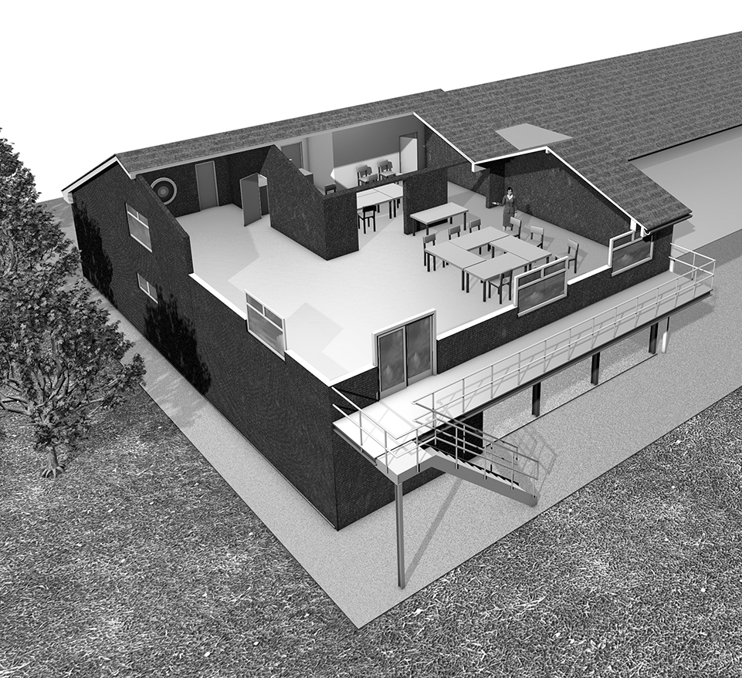
We also want to create a space for village organisations to use and this in turn will generate an income for the group, as it did in the past, so we are not fully reliant on out event portfolio. Our large events will still run but like any other voluntary operation finding help to run an event is becoming increasingly difficult.

The current HQ remains largely unchanged except for a lift installed in the main foyer of the HQ to enable access for all to the first floor. The extension is to the back and to the right of the HQ when you look at the building from the road.
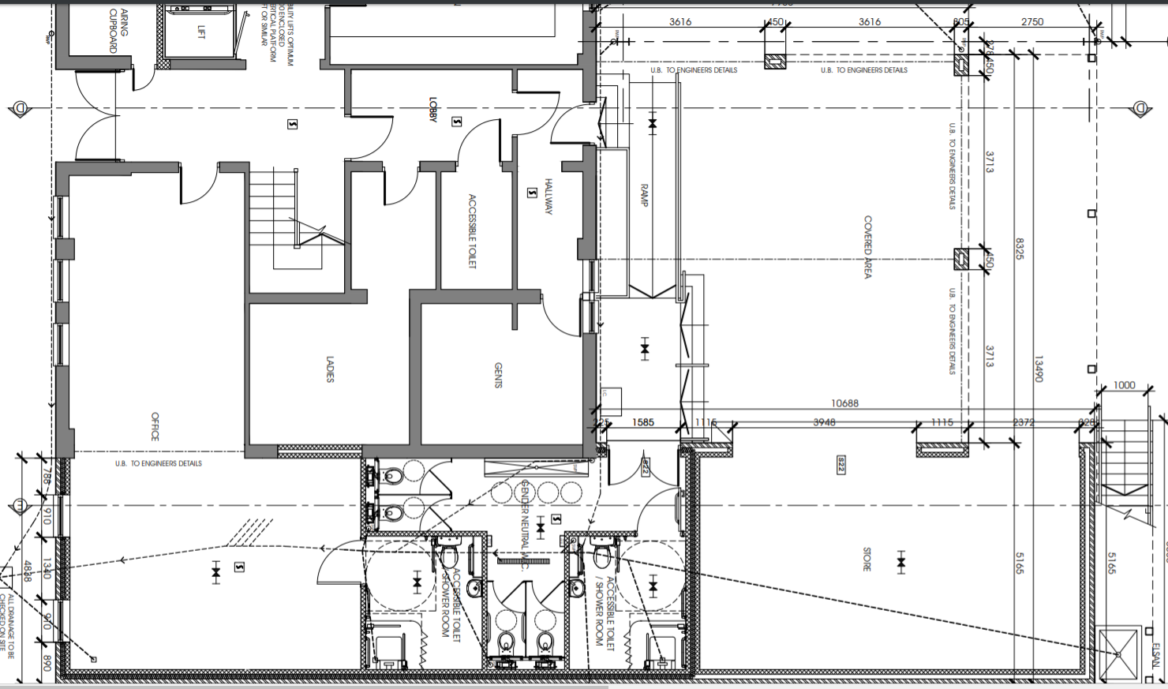
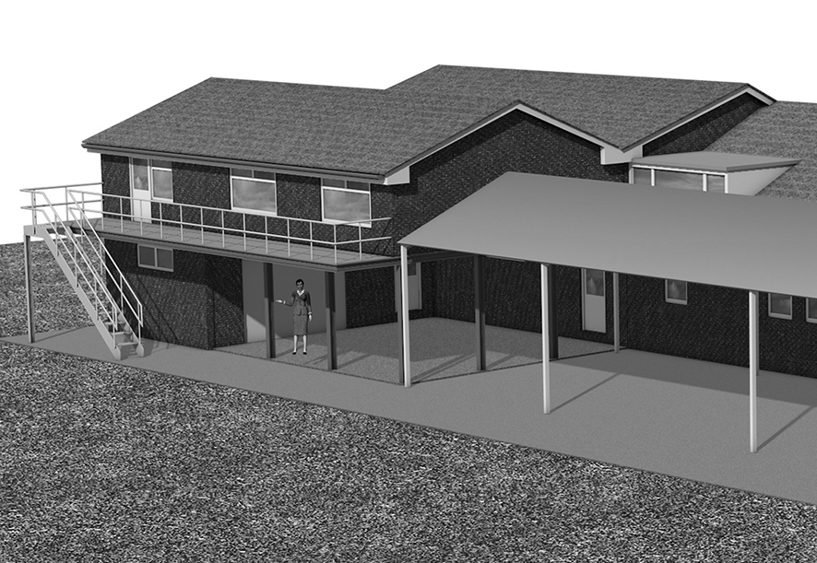
As you can see, we are creating a large L shaped meeting room complete with balcony, toilet and small kitchen upstairs. This will enable meetings to be self-contained and will even provide access to the canopy via the outside stairs. The new canopy will be constructed from steel (like the MAC) and also the levels will be raised so you walk out of the HQ fire doors and it is the same level.

On the ground level will be a store area, new toilets and showers and a pot wash area. The leader’s room will also be extended to give more space and a shower and toilet area for them to use.

These are the plans for the ground floor, showing the existing HQ in the bottom left with the new addition wrapped around the right hand side and the canopy to the left which runs most of the length of the HQ.
More plans and diagrams can be found on our website http://rollestonscouts.org.uk/hq-extention/
BECOME AN RSG VIP
This is a fundraising initiative to raise a minimum of £50k to assist in the funding of the new extension to the HQ. The reason of the extension is twofold. Firstly, to give the Group an additional meeting room to enable us to expand and create new spaces for the children of the community to enjoy Scouting in the village. At this moment we have over 50 children that cannot access the group due to the fact we are full and also have no space to expand at the times the three sections need to meet. Secondly this will also create an asset that the village can use when we are not. It will be fully accessible and kitted out for everything from meeting, events and even keep fit.
So how can you help.
We are selling RSG VIP tickets. This is basically a loan to enable the build as all grant funding that we were hoping to attain is obviously all aimed now at the COVID19 pandemic.
Cost
- £550 or 2 for £1000
Benefits.
- Priority free general admission to any of our events whilst the loan is active. This can be a saving of over £50 per year.
Repayment and options
- You gift us the loan and the ticket remain active for 15 years.
- We repay the loan in full and the ticket is cancelled on repayment.
We aim to repay all the loans in ten years of the ticket being purchased. You will receive a VIP pass with your name on which is non-transferable and photo ID will be asked for on entry to our events.
With the outbreak of COVID19 it’s been hard for many working families and this simply may be out of the question at this time, so we are asking that you send this on to maybe relatives, friends and supporters of the group at present and indeed people that have been involved or benefited from the group in the past. Have they been a leader, helper, Beaver, Cub, Scout maybe even a Venture Scout or a Rover back in the day? Well this is their opportunity to give the group a helping hand. As with all other charities our fundraising has been hit very hard and we are committed to seeing this project through as we believe it not only has massive benefits for the group but also it will create a fantastic venue to be used for the village organisations.
With the addition of the new meeting room this will generate an income. The idea is that the generated funds will pay for the HQ running costs and the future development of the group rather than solely relying on the large fundraising events we hold.

Application forms are available from http://rollestonscouts.org.uk/rsg-vip-application-info/

